Archive Procedure (Conceptual ETL)

Problem Statement
In large systems, old transactional data slows down queries. To improve performance, old orders (older than 2 years) should be moved to a history table.
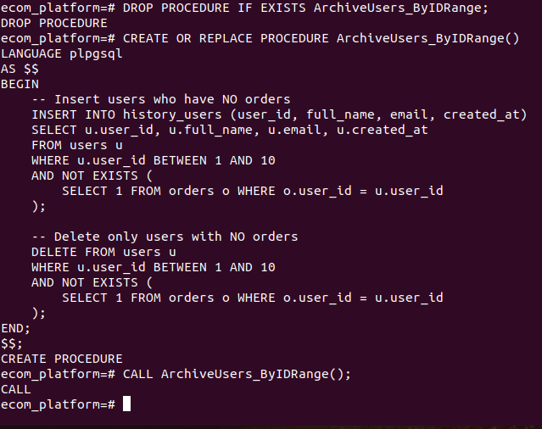

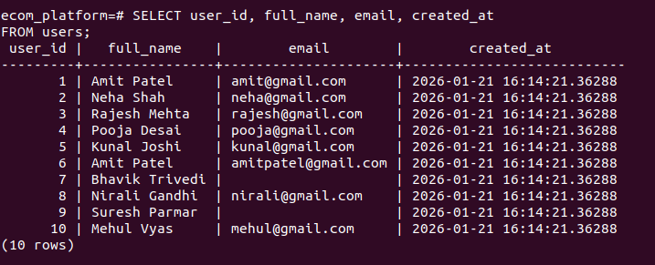
- SELECT user_id, full_name, email, created_at FROM users;

Explanation
This procedure:
- Finds orders
- Moves them to history_orders
- Deletes them from the active table
This helps optimize performance and reduce main table size.

Views (Data Abstraction)

Problem Statement
Complex joins and IDs make reporting difficult. Views help simplify data access by hiding internal table structure.

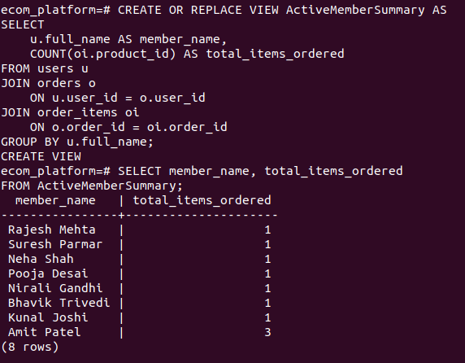
Explanation
- The ActiveMemberSummary view summarizes customer activity by showing each user's name and the total number of products they have ordered.

